Final Project Design Phase
Computer Science - Week 11
Oct 3, 2026 - Version 0.0.4

For complete instructions and project ideas, refer to the assignment in Canvas. Specifically, review the final project requirements before you continue below. If you have not reviewed the project requirements in Canvas (you might have to go to the modules view and check the current or past week's content), you will not be able to properly complete the parts below. In addition, it may be helpful to review the information on this Drafter documentation page.

0) Project Planning and Preparation
Successful programmers spend time planning before they begin coding. After reviewing the project requirements, answer the following questions to help guide your design and development process.
- What concepts from class or previous assignments might help you complete this project? Which programming concepts (loops, conditionals, lists, classes, etc.) do you expect to use? What programming skills do you want to improve while completing this project?
This project will use concepts like functions, routes, states, dataclasses, lists, loops, inputs, and if statements. I would like to improve my ability to originate larger problems and manage data across multiple pages to create a user-friendly drafter interface.

- Which parts of the project do you expect to be the easiest for you? The hardest? Why?
The easiest part of the project will be the calculations because I already have a strong understanding of the calculations because of my MECHE background. However, I feel that I will struggle with the user interface and finding an effective way to define mechanical devices and their relationships.

- Even though you have not yet designed the final project, estimate which tasks will likely require the most time and effort? Which features or components should be implemented first?
As previously stated, I feel that the user interface will be extremely difficult; it is for this reason that I feel that it will take the largest amount of time, even with the help of an LLM. I will focus on inputs and the user interface first to find out what is actually possible and how that will affect how my calculations will have to be completed because there is no point in starting with the equations if they won't work with the user interface.

- What distractions might interfere with your work and how will you minimize them? What resources will you need available while working? What questions, if any, do you still have about the assignment requirements?
My biggest distractions will be other coursework; for this reason, I will attempt to complete other coursework before working on my project. I will use drafter materials and LLM’s to complete the final project. At this time, I do not have any questions about the project or its requirements.

1) Site Diagram
Create a mock-up of your planned website. We suggest you make the mockup on paper, although you can also use software like PowerPoint or Slides to make a mockup. There is other design software that could also be used, but we strongly encourage you to keep it simple. Do not spend more than 15-30 minutes detailing the mock-up. Your goal should be to make a very quick and dirty diagram, to show that you have some kind of idea.

We recommend drawing each page as a rectangle, and laying out the text, buttons, and other components inside. Then, use arrows to indicate links between pages. Label each page the way you will name each function, and then put labels on the arrows to indicate what the button links. Also write down any parameters that should come into the pages.

In addition to the pages and routes, write down what fields your `State` will have, both their names and types. Think clearly about what data will need to be persistent across the entire website.

Add photo(s) or screenshot(s) of your website mock-up and labeled diagram on the next page.
State
mechanisms : list[Mechanism]
project_name : str
selected_mechanism : int
total_input_force : float
total_output_force : float
Mechanism
name : str
mechanism_type : str
input_force : float
output_force : float
angle : float

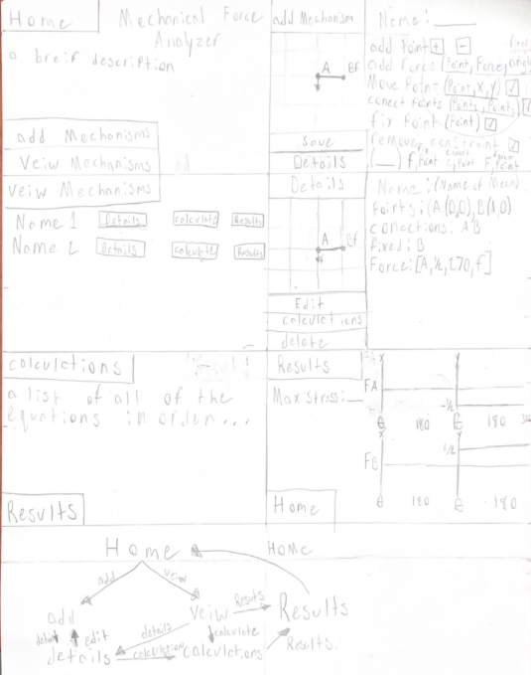

2) Implementing Requirements
This table should serve as a draft for how you will implement the requirements into your final project. You may change your ideas later on, but your final site must fulfill all the requirements.

Requirement | Implementation
Purpose/Functionality  A 1-2 sentence description of the purpose or functionality of your site | This website will allow users to create simple mechanical systems consisting of forces, joints, and mechanical components. The program calculates output forces and estimates loads on the mechanisms so users can evaluate whether a design meets its requirements.
State Dataclass Attributes  Minimum of 4 attributes, one of which must be a list/dict of instances of your second dataclass.  Briefly describe each attribute, its type, and how it will be meaningfully modified throughout the site. | mechanisms : list[Mechanism]  Stores all mechanical components entered by the user. Components can be added, edited, or removed throughout the site.  project_name : str  Stores the name of the current project and can be modified by the user.  selected_mechanism : int  Tracks which mechanism the user is viewing or editing.  total_input_force : float  Stores the total input force applied to the system and updates whenever a mechanism is modified.  total_output_force : float  Stores the calculated output force of the mechanical system.
Second Dataclass  Your second dataclass, including its attributes, their types, and how they will be meaningfully modified (if they are modified) | Mechanism  name : str  mechanism_type : str  input_force : float  output_force : float  angle : float  name - Name assigned by the user.  mechanism_type - Lever, gear, pulley, beam, etc.  input_force - Force applied to the mechanism.  output_force - Calculated force output.  angle - Operating angle of the mechanism.
Routes (minimum 7)  The names of your route functions | home_page()  add_mechanism()  view_mechanisms()  mechanism_details()  edit_mechanism()  calculate_forces()  results_page()  about_page()
Pages (minimum 5)  A brief description of the pages in your site | Home Page  Main navigation page for the project.  Add Mechanism Page  Allows users to create a new mechanism.  View Mechanisms Page  Displays all mechanisms currently stored.  Mechanism Details Page  Displays detailed information about one mechanism.  Calculate Forces Page  Runs force and stress calculations.  Results Page  Displays calculated system results.
User Input (minimum 3)  Description of user input components (TextBox, TextArea, CheckBox, or SelectBox) and their purposes  For more information on these input types, see Drafter Documentation. | TextBox  Used to enter a mechanism name.  SelectBox  Used to select the mechanism type (lever, gear, pulley, beam).  TextBox  Used to enter the applied force.  TextBox  Used to enter the mechanism angle.  CheckBox  Used to identify whether a member is fixed or free to move.
If Statements (minimum 3)  Brief description of what will be evaluated in your if statements and how they will meaningfully change the logic of the site | if mechanism_type == "Lever":  if support_fixed:  if stress > allowable_stress:
Loop (minimum 1)  This loop must iterate over the list/dict of dataclass instances in your State attribute.  Description of this loop and why it is meaningful to the site | for mechanism in state.mechanisms:  It processes every mechanical component and contributes to the final force calculations and display of results.

LLM Conversation
If you used an LLM in any part of this work, copy and paste every part of that conversation below. Otherwise, you may be given a zero for the assignment. Obviously, these words will not all be yours, and this is the exception to the requirement at the top of this assignment that all responses be in your own words. If you did not use an LLM to assist you in this assignment, simply say so below.
Me
Using your knowledge of what I have done for my project so far, given in the 2 attached files and question 2, can you sum up what I need for each part of question 2? Don't give me direct answers for each part; I would just like to have an idea of what I should be doing for each part.
The attached files were the project requirements/rubric and the second was my doc CS1 final project 0: from last week. I also copied all of question 2 and gave it to copilot.
Copilot
Based on your project idea and the project requirements, Part 2 is essentially asking you to create a plan showing how your website will satisfy each requirement before you start coding.
For the purpose/functionality, explain what your website does and what problem it solves for the user.
For the State dataclass attributes, think about what information needs to exist across the entire website and be updated as the user interacts with it. Remember that at least four state variables must be meaningfully modified, and one of them must be a list or dictionary containing instances of another dataclass.
For the second dataclass, identify the main object your website is centered around and determine what information each instance of that object needs to store.
For routes, list the functions that a user can navigate between. Think about the actions users can perform and the pages needed to support those actions. Make sure you have at least seven routes.
For pages, describe what appears on each page and how that page contributes to the website's overall purpose. Make sure you have at least five distinct pages.
For user inputs, identify the information users must provide to create, edit, or analyze data within your application. These should be meaningful inputs that affect how the site behaves.
For if statements, think about decisions the program must make. These should not exist just to meet the requirement; they should change calculations, displayed information, navigation, warnings, or program behavior in a meaningful way.
For the loop, identify a place where the program needs to examine multiple stored objects. Since the requirements specify that the loop must iterate through the list or dictionary of dataclass instances, focus on a task where processing all stored objects makes sense.
Overall, Part 2 is less about writing code and more about proving that your planned design will satisfy all of the project requirements before development begins.

Final Submission
When you are finished, download this file as a Word Document (docx) and upload the file to the appropriate assignment on Canvas.

